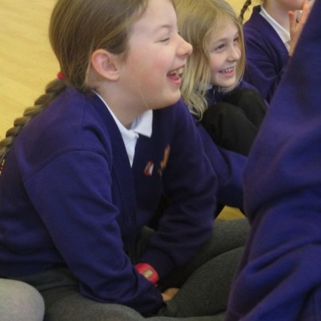
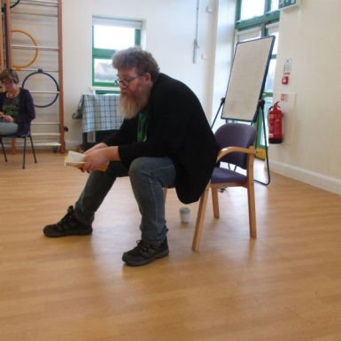

-
School Website
For the latest news, photos and information, visit the Oak Class pages on the Nar Valley Federation website.
www.narvalleyfederation.co.uk then click on Castle Acre – Our Learning - Classes – Oak Class

‘Funtrition’
An informative 'Funtrition' lesson delivered by Premier Sports was enjoyed by Oak Class on Thursday 1st February. Focusing on the ‘Eat well; Move well; Sleep well’ message, the session gave the children advice and tips about how to keep their bodies healthy through participation in fun (and sometimes tiring) activities.

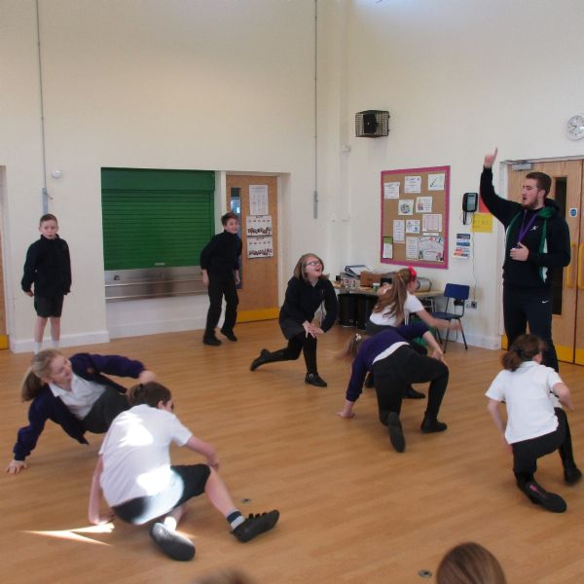
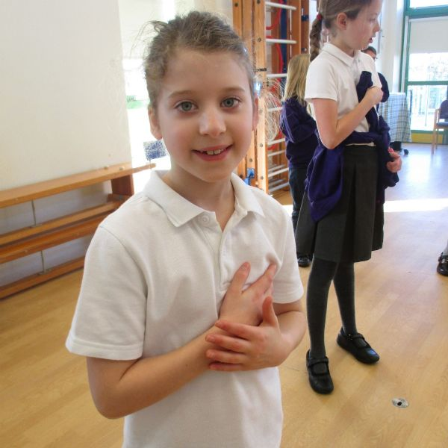
School Council
Oak Class have three democratically elected School Council members – Freddie Holt (Yr6), Sean Bolton (Yr5) and Bosco Williams Eley (Yr4). Currently Council are meeting with suppliers of playground equipment and discussing options before presenting the information back to classes.
This half term, they will also be busy organising a fundraising event for our school charity, ‘Save the Children’.
Poet Visits Castle Acre
On Wednesday 31st January, the poet and author A. F. Harrold (Ashley) spent the day with us at Castle Acre. He held hour long workshops throughout the day aimed at promoting a love of poetry within the children. The children in Oak Class thoroughly enjoyed listening to readings of his poems and were transfixed by his performance. He helped them to write a group poem and gave loads of tips on how to start, write and then improve their work. Pieces inspired by Ashley’s visit are currently on display in the hall; please take time to have a look.
"The only thing I want is for him to come again!" – Isabella
“We should do more things like this as it makes writing poetry more interesting and fun." - Freddie

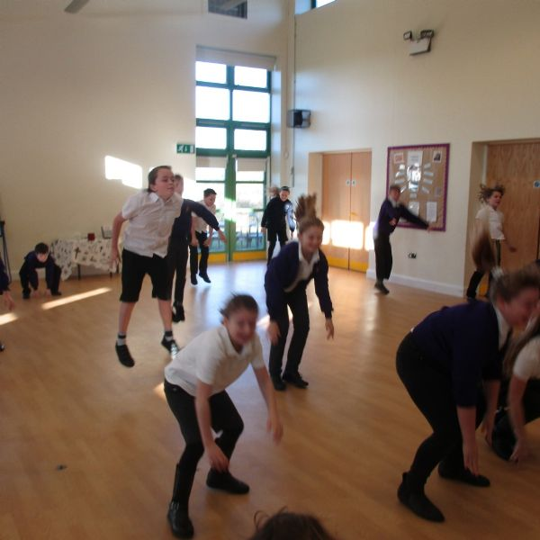
Welcome back! We hope you enjoyed the break and that your children are rested and ready for all the exciting learning activities, events and trips that have been planned for the next six weeks. ‘Diary Dates’, giving further information, was sent home via ‘Pupil Post’ just before half term. If you missed it, please ask for a copy at the main office.
News from Oak Class - February 2018

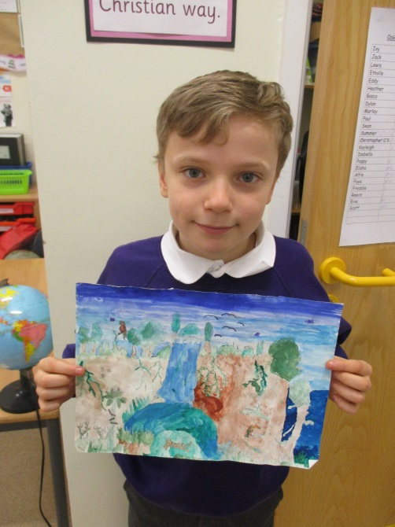
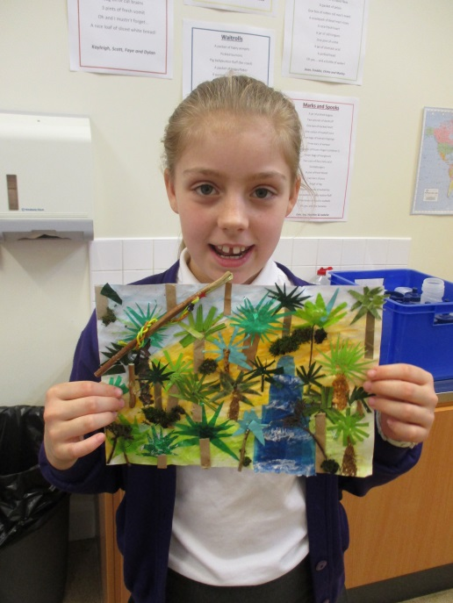
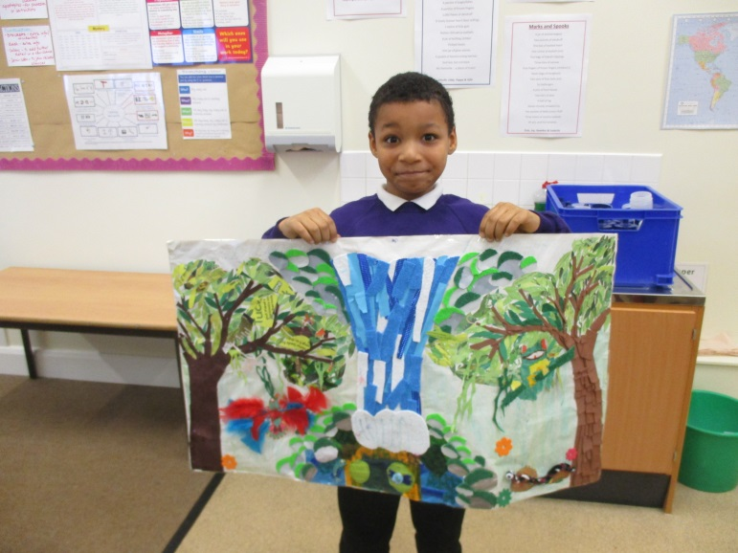
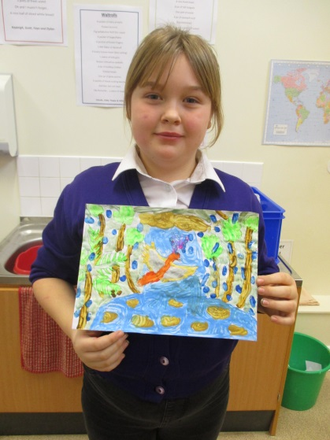
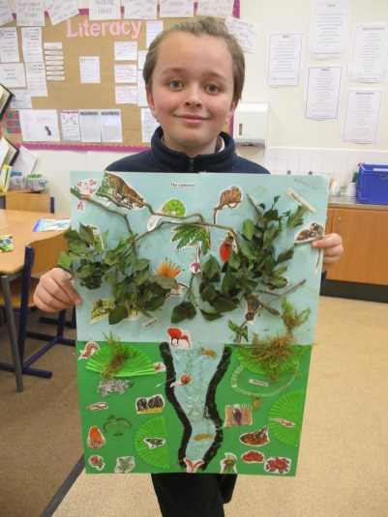
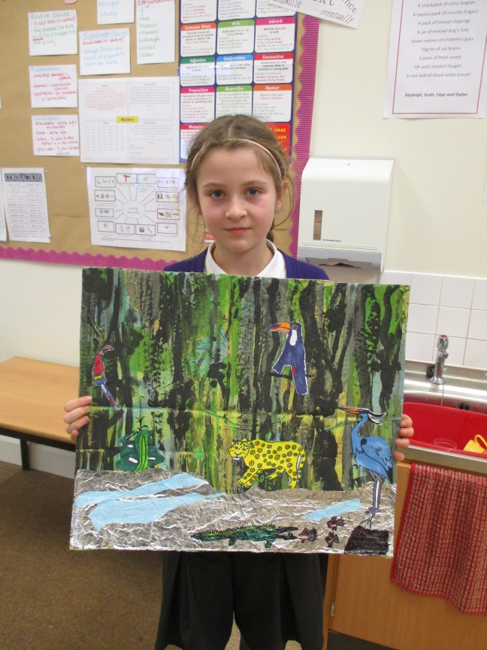
Homework
Many thanks for your continued support regarding homework. The children produced excellent fact files on Machu Picchu and stunning rainforest artwork.
We organised a class viewing of the finished pieces and then encouraged the children to share positive thoughts and opinions of each other’s work.
The standard of work was very high and the children were very inventive with their ideas.

