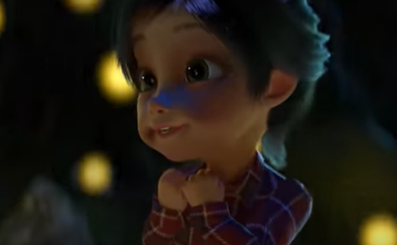
How does the little girl feel?
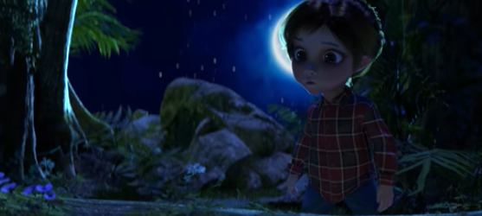
What does she hear in this part of the video? (0:36)
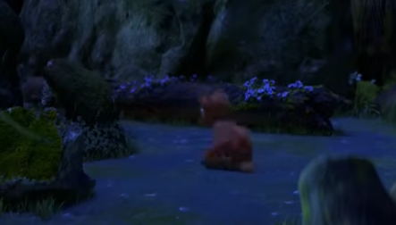
Why do you think the animal decides to sneak away?
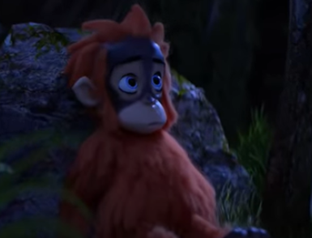
How does he feel?
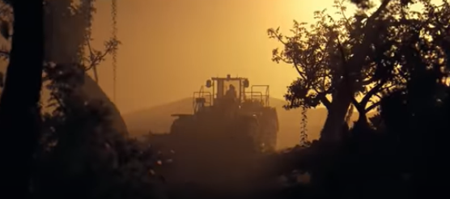
What is happening here?
Do you think this is a good thing or a bad thing?

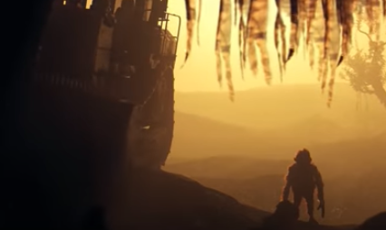
How do you think the animal feels here?

