Can you create your own magnetic game?
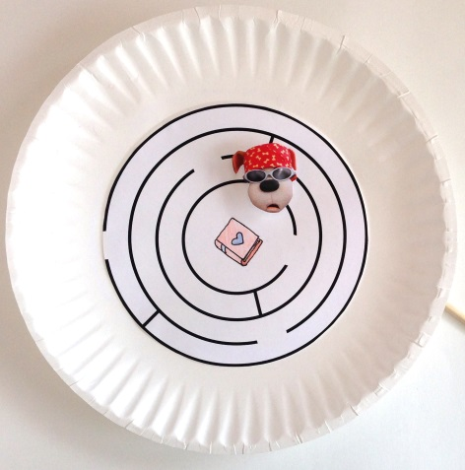
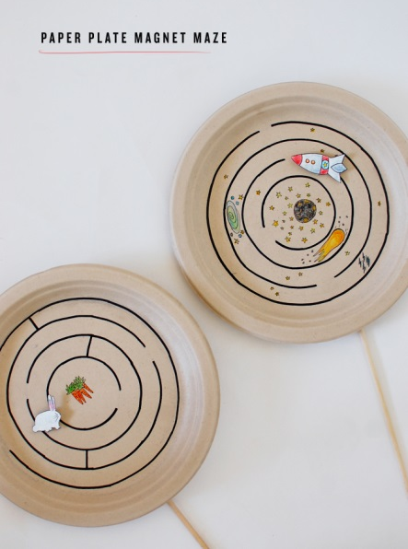
Create a magnetic maze. How do you think this works?
Or a magnetic race track ?

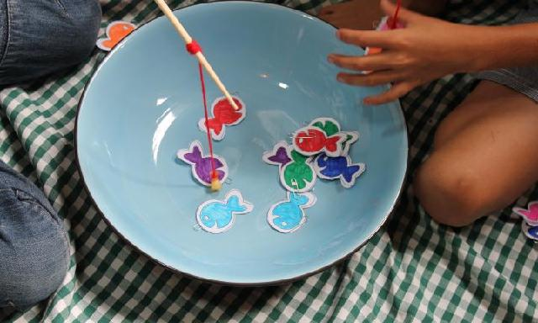
A magnetic fishing game if you have paper clips and a suitable magnet.

