Spectacled Bears
The spectacled bear (Tremarctos ornatus) is probably the only bear species which is native to South America. The South American bear is also called Andean short-faced bear. The Florida spectacled bear which has long become extinct is thought to be the closest cousin of spectacled bear.
Adult males weigh 220 to 440 pounds while females weigh only 77 – 181 pounds. This shows that females are only half the size of males. The head-body length is measured at 120 to 200 cm. It has the shortest muzzle of all bears—the second shortest is of giant panda.
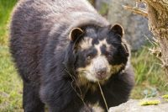
It has brown shaggy coat which goes black at times. The bear earns its name because of the prominent yellow rings encircling the eyes.
Spectacled bears are found in eastern Panama, western Venezuela, Ecuador, north western Argentina, western Bolivia, and Peru. They occur throughout the Andes Mountains.
While polar bear is the most carnivorous, the spectacled bear is the most herbivorous species of all bears. That is to say that only 5% of its diet consists of meat. The spectacled bear eats palm leaves, orchid bulbs, bromeliads, palm nuts, cactus, fallen fruits, frailejon, corn, honey, sugarcane, and bamboo hearts. It also consumes rodents, birds, rabbits, mice, lapwings, arthropods, and carrion.
The spectacled bear makes home in a wide variety of habitats at high altitudes. The bear’s habitat includes dry forests, scrub forests, grasslands, and cloud forests. Their habitats are located at 3,300 and 8,900 feet high above the sea level.
Like an American black bear, the spectacled bear is also an arboreal species—living most of its life in trees. It can afford to become active any time during day and night possibly because the bear can escape predators by climbing up the trees.
The mating season occurs in April and June. The female produces 1 to 3 cubs after a gestation period of 5 to 8 months. The bear cubs weigh only 300 grams at birth.
The average lifespan of a spectacled bear is about 25 years in the wild.
Cougars are probably the only predators of spectacled bear cubs.
More information
The spectacled Bear is also known as the Andean bear because they live in the Andes Mountains. If you’ve ever seen a picture of this bear you will know how it got its name! The face markings of the spectacled bear make it look like it is wearing glasses or spectacles.
This is the only bear species that can be found only in South America in the forests of the Andes Mountains. They are thought to be the last living bear from the otherwise extinct short-faced bear family.
Spectacled bears eat a wide variety of foods including rodents, birds, berries, grasses and fruit but their favourite is the Bromeliacae plant. These bears are excellent climbers with short but strong legs. They build nests high in trees for sleeping and eating in.
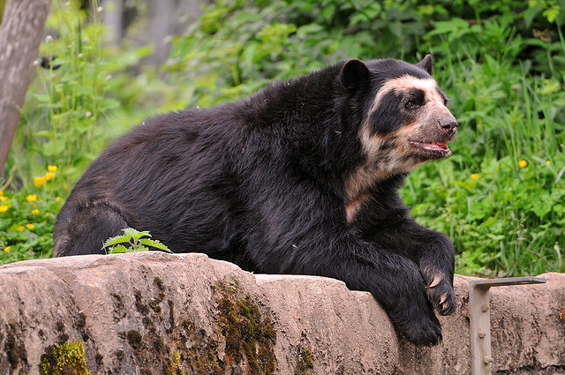

Interesting Spectacled Bear Facts:

Spectacled bears can reach 5 to 6 feet in length and weigh up to 340 pounds. Males are almost two times bigger than females.

Body of spectacled bear is covered with black or reddish-brown fur. Patches of creamy fur can be seen on the chest, throat and around eyes. Pale marks around eyes look like spectacles, which is why these animals are called "spectacled" bears.

Each spectacled bear has unique creamy markings which facilitate identification of individuals in the wild.

Spectacled bear has muscular body and round head with short snout and strong jaws.

Front limbs of spectacled bear are longer than hind limbs and equipped with sharp claws which are used for climbing. Despite being large, spectacled bear is fast and agile climber.

Spectacled bear spends majority of time on the trees. It builds a platform out of the branches and twigs and uses it for sleeping and eating.

Spectacled bear is diurnal animal (active during the day).

Spectacled bear is an omnivore (it consumes both plants and animals). Its diet consists of various plants (bromeliads, palms, cacti…), berries, honey, fruit, eggs, insects, small birds and mammals.

Main predators of spectacled bears are mountain lions and jaguars.

Spectacled bear is solitary creature that occasionally gathers with other spectacled bears when food is abundant.

Spectacled bears live in warm climate that provides enough food throughout the whole year. Because of that, spectacled bears don't hibernate.

Mating season of spectacled bears lasts from March to October.

Pregnancy in females lasts between 5.5 and 8.5 months and ends with one to three cubs. Young bears are blind until the 42nd day. They completely depend on their mother during the first few months of their life. Mother sometimes carries her cubs in her front paws while walking on the hind feet.

Young bears will learn all skill required for successful survival from their mother. They usually leave mother after one or two years, when they are old enough to begin independent life. They reach sexual maturity at the age of 4 to 8 years.

Spectacled bears can survive up to 38 years in captivity. They live much shorter in the wild.
Endangered

Spectacled bear is threatened by habitat loss and by killing because of the fur, meat and body parts (used in traditional Asian medicine). Exact number of remaining spectacled bears in the wild is unknown, but it decreases rapidly. These animals are listed as vulnerable, which means that they could soon become endangered. Their habitat is being destroyed by a number of things such as farming, lumber and mining operations. They also sometimes are hunted by farmers because as their habitat shrinks they may stray onto farmland and eat the crops that have replaced their natural diet. Also some farmers think that the bears will eat their livestock although they do not eat large quantities of meat. They are hunted for their gall bladders which can fetch a high price in the international market as they are valued in traditional Chinese medicine.

