PE
Have a go at some of these activities.
- Find a cushion and balance on it ( but not on your feet). How long can you hold your balance for?
- Use a plate (ask first and one that won’t break !) How many parts of your body can you balance it on eg head, knee. How long can you balance it on the part for? Which part of your body was it easiest/hardest to balance it on?
- Use the bottom step of the stairs or one outside. Count how many times you can step up and back down on the same step in 30secs?
- Standing press ups against a wall. Stand with your feet hip width apart and place your hands on the wall. (make sure they are clean if you are inside- that is your hands not the wall!)How many can you do in 30 secs.
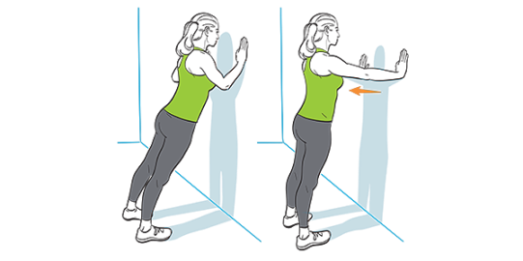

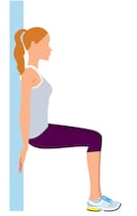

- Hold a wall sit for 30 secs or for as long as you can.

- Time how long you can balance on your favourite leg?
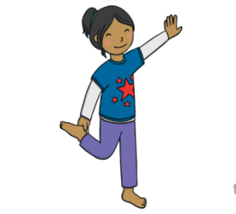
- Try your non favourite leg.

- Now try with your eyes closed. Important close your eyes first before you balance on one leg. How long can you balance for?

Top Tip : take care you have made sure your surroundings are safe!

