ORANGUTAN

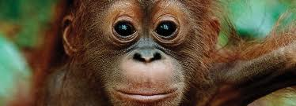

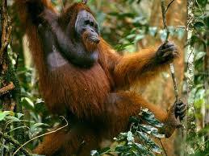

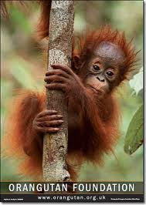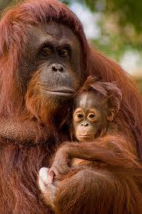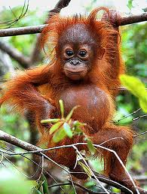

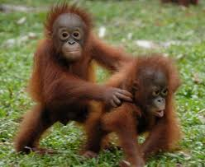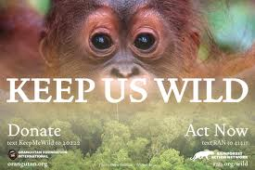


Orangutan Foundation - Indonesian Forest Facts

- Indonesia has 1,127 threatened species, the fourth highest in the world

- There are 39-42 primate species found in Indonesia

- Indonesia’s forests represent 10% of the world’s remaining tropical forests

- Recent estimates suggest that 98% of Indonesia’s natural rainforest may be destroyed by 2022

- From 2000 to 2005 Indonesia’s lost 2% of its forests every year

- Indonesia has one of the world’s highest annual deforestation rates. From 1990 to 2005 total forest area was reduced by 24%


FACEBOOK GROUP:
HALLOWEEN CANDY DESTROYING ORANGUTAN HABITAT
Much of the halloween candy we eat contains palm oil. If you are concerned about Orangutan conservation and deforestation due to non-sustainable palm oil production in Indonesia and Malaysia, this is your group. The certification process for sustainable palm oil is in the early stages of implementation so many people are choosing to buy products that do not contain palm oil. Each consumer should make their own decisions on what products they purchase and what companies they would like to support.
We need to send out messages, through phone calls and e-mails to get these companies to stop using palm oil in their products, It is very simple, go on a website of the companies listed below and find their 'contact us' button. It will bring you to a page and you can then state your interest in saving Orang habitat. Here is an idea of what your message could say:
"Thank you for taking the time to read this. As I'm sure you are aware, many of your products contain palm oil. However, I'm unsure of whether or not you know that palm oil is one of the leading causes of Orangutan habitat being destroyed. All that I, like so many others ask, that you refrain from the use of palm oil in all of your products. If this is not possible, perhaps the company can donate to replenishing or saving undestroyed habitat."
Obviously in your own words, make sure to make it personal as well. I know this seems like a lot of work, but if you have ever seen an Orangutan and got the chance to see them as their natural, curious selves, then you would do this for them. All I ask is for some of your time. Some of the main companies that have some of their products made with palm oil are Hersheys, Nabisco, Lindt, Nestle, and Mars. The full list of all candy that has or doesn't have palm oil in their products is listed below.

SAY NO TO PALM OIL
http://www.saynotopalmoil.com/
Palm oil is an extremely popular oil used in many products by a wide range of companies. It is used in over 50% of baked foods, confectionery, cosmetics, body products and cleaning agents in your local supermarkets. But in many countries, there is no law on the compulsory labelling of palm oil, therefore companies usually don't label it on their products. Instead, they hide palm oil under the name of 'vegetable oil', or over 25 other names.

Orangutan numbers are plummeting at a dangerously fast rate, all for our sugary, pre-packaged snack foods and fragrant, chemical-filled soaps and shampoos. We have a choice, orangutans do not.
There are thousands of Bornean and Sumatran animal species under threat due to palm oil plantations. Their dense, bio-diverse habitat is being destroyed at an alarming rate to make way for these large-scale plantations, leading to the endangerment of their species.

The animals are not only losing their habitat, but the roads constructed for the plantation workers expose the forest to poachers and animal smugglers.
These roads allow the poachers and smugglers to access the forest and capture the exotic wildlife within. These animals are often sold on the illegal pet trade market, used in the entertainment business, slaughtered in order to make medicines, killed for their fur, skin or ivory.



