Answer these division questions by grouping the counters on your table! Show me your jottings.


Kian has 10 football stickers. He shares them between his 2 friends. How many stickers do they get each?

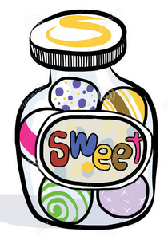
Lottie has 15 sweets. She shares them between 5 children. How many sweets does each child get?

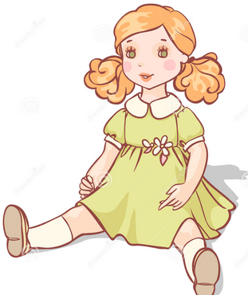
Katie has 12 dolls. She shares them between 2 of her friends. How many dolls do they have each?

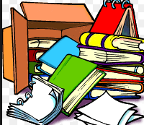
There are 20 books in total and they are packed in boxes of 10. How many boxes are there?


8 flowers are shared between 2 vases. How many flowers go in each vase?


The milkman has 15 bottles of milk, if he delivers 5 bottles to each house, how many houses will he deliver to?

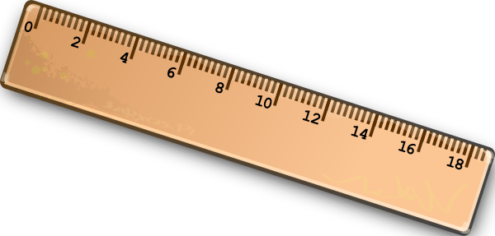
Mrs Evans decided to share 20 rulers out between her group of 5 children, how many rulers did each child get?

