
Kian has 20 football stickers. He shares them between his 2 friends. How many stickers do they get each?
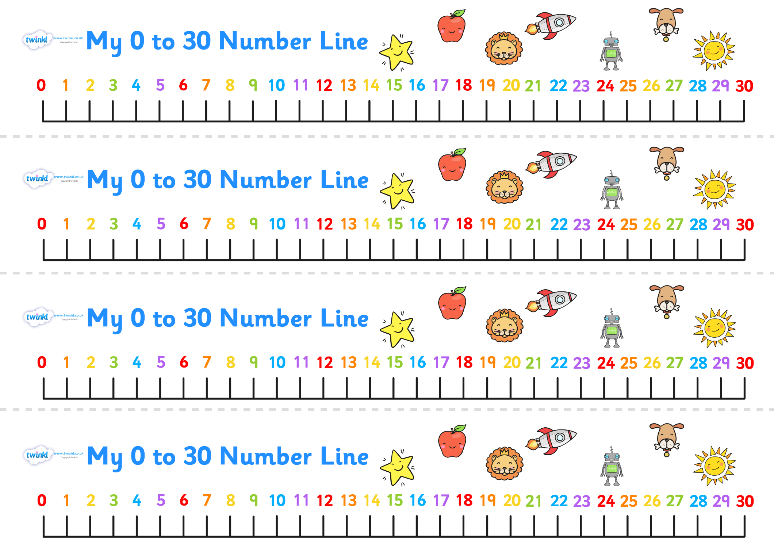

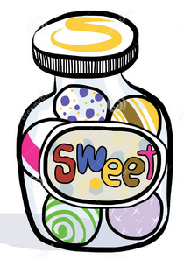
Lottie has 25 sweets. She shares them between 5 children. How many sweets does each child get?

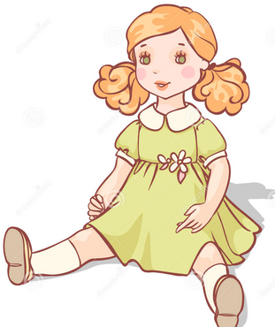
Katie has 15 dolls. She shares them between 3 of her friends. How many dolls do they have each?

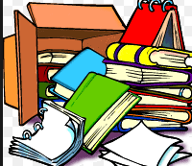
There are 30 books in total and they are packed in boxes of 10. How many boxes are there?


10 flowers are shared between 2 vases. How many flowers go in each vase?


The milkman has 18 bottles of milk, if he delivers 3 bottles to each house, how many houses will he deliver to?

